KUMARAGURU INTRA IDEATHON’26
Think. Research. Innovate.
A 36-Hour Research & Innovation Challenge for First-Year Students
6 & 7 October 2026 | MGate
About Ré
Ré – Centre for Exploratory Research is a student-driven research platform at Kumaraguru College of Technology, established to cultivate a strong culture of research, exploration, innovation, and problem-solving among students.
Ré provides students with opportunities to identify real-world problems, explore research-driven approaches, develop projects, and work collaboratively across disciplines. Through mentorship, technical guidance, project development, funding opportunities, and research exposure, Ré supports students in transforming ideas into meaningful solutions.
The centre aims to create an environment where students can move beyond conventional learning and actively explore, experiment, research, and innovate.

About Kumaraguru Intra Ideathon
Kumaraguru Intra Ideathon’26 is a 36-hour research and innovation challenge conducted exclusively for first-year students of Kumaraguru College of Technology.
The Ideathon is designed to provide students with an early introduction to the research process — from understanding a problem and identifying possible approaches to developing, refining, and presenting a solution.
Participants will work in teams of 4–5 members and select one problem statement from a curated set of approximately 105 real-world problem statements contributed by the Research Circles of Ré.
Through multiple stages of review and mentorship, participants will research their selected problem, understand its context, develop an initial solution approach, and progressively transform their idea into a project or prototype.
KII’26 – The Concept
Unlike a conventional ideathon built around a single common theme, Kumaraguru Intra Ideathon’26 does not have a predefined overarching theme.
Instead, participants will choose from a diverse collection of real-world problem statements curated by the Research Circles of Ré. These problem statements span multiple research and innovation domains, allowing students to explore challenges based on their interests.
105 Problem Statements
7 Research Circles × 15 Problem Statements
Research Circles
- Automotive Research
- Bioscience Research
- Educational Research Circle
- Design Research Circle
- Textile Research Circle
- Renewable Energy
- Environmental Science & Sustainable Systems
Participants must select one problem statement from the given 105 problem statements. Participants cannot submit an independently proposed problem statement.
Event Details
Details | Information
Event | Kumaraguru Intra Ideathon’26
Eligibility | First-year students of KCT
Team Size | 4–5 members
Duration | 36 Hours
Date | 6 & 7 October 2026
Venue | MGate
Organized By | Ré – Centre for Exploratory Research

Selection Process
The selection process is designed to allow students to develop their ideas progressively, beginning with an online submission and leading into an intensive 36-hour in-person Ideathon.
Round 1 – Abstract Submission
Participants will review the 105 problem statements provided by the Research Circles and select one problem statement that aligns with their interests.
Teams must submit the required details through the designated submission format.
Submission Requirements
- Selected Problem Statement
- Team Details
- Completed PPT/Abstract Template
- Understanding of the Problem
- Initial Solution Approach
Timeline
Submission Opens: 28 September 2026
Abstract Submission Deadline: 4 October 2026
Zeroth Review: 5 October 2026
Shortlist Announcement: 5 October 2026

Zeroth Review
The Zeroth Review serves as the initial evaluation stage before the 36-hour Ideathon.
The submitted abstracts will be reviewed by student mentors, focusing on the team's understanding of the selected problem and the proposed initial approach.
The review will help identify teams that progress to the in-person Ideathon.

Round 2 – 36-Hour In-Person Ideathon
Shortlisted teams will participate in the 36-hour on-campus Ideathon on 6 & 7 October 2026.
During the Ideathon, teams will:
Understand → Research → Ideate → Develop → Refine → Present
Participants will work on their selected problem statement, conduct research, develop their solution, receive feedback through structured reviews, and continuously refine their project.

Review Process
The Ideathon will follow three progressive review stages.
First Review
6 October 2026 – Afternoon
The first review will assess the team's understanding of the problem, research progress, proposed solution, and development direction.
Review Panel: Student Mentors

Second Review
6 October 2026 – Night
Teams will present their progress and demonstrate how they have developed and refined their solution based on feedback from the first review.
Review Panel: Student Mentors

Final Review
7 October 2026 – Afternoon
The final review will evaluate the completed solution, its development, research basis, feasibility, innovation, and presentation.
Review Panel: Student Mentors + Faculty/Staff

Valedictory Ceremony
Following the Final Review, a Valedictory Ceremony will be conducted to mark the culmination of Kumaraguru Intra Ideathon’26.
The ceremony will include the announcement and recognition of the winning teams, along with the celebration of the students' research, collaboration, and innovation journey throughout the 36-hour Ideathon.

Why Participate?
KII’26 is designed to give first-year students their first structured experience of research and innovation.
Participants will get an opportunity to:
- Gain early research exposure
- Learn problem identification and analysis
- Work in an interdisciplinary team
- Receive mentorship and guidance
- Develop ideas into projects and prototypes
- Explore innovation and entrepreneurship
- Access project funding opportunities
- Continue project development through Ré
- Explore Ré internship opportunities
- Get opportunities to participate in national-level ideathons
- Collaborate with the Ré Research Forum

From Ideathon to Research
The Ideathon is not intended to end with the final presentation.
Promising ideas can progress through a continued development pathway:
Ideathon
↓
Mentorship
↓
Project Development
↓
Project Funding
↓
Prototype / Research Development
↓
National-Level Ideathon / Ré Internship
This pathway enables students to continue developing their ideas beyond the 36-hour event.

Opportunities for Top 5 Teams
The Top 5 Teams will receive access to the following opportunities:
- Project Funding
- Ré Internship Opportunity
- National-Level Ideathon Opportunity
- Continued Mentorship
- Support for Research & Project Development
These opportunities are intended to help promising ideas progress beyond the Ideathon and into further project or research development.

Process Flow
28 September 2026
Registration & Submission Opens
↓
4 October 2026
Abstract Submission Deadline
↓
5 October 2026
Zeroth Review
↓
5 October 2026
Shortlist Announcement
↓
6 October 2026
Orientation
↓
6 October – Afternoon
First Review
↓
6 October – Night
Second Review
↓
7 October – Afternoon
Final Review
↓
7 October 2026
Valedictory Ceremony & Winner Announcement

Orientation
The shortlisted participants will attend an Orientation Session on 6 October 2026 before the Ideathon begins.
The orientation will provide participants with clarity on:
- Ideathon structure and timeline
- Rules and regulations
- Review process
- Expectations from teams
- Submission and presentation requirements
- Available mentorship and support

Rules & Regulations
General Rules
- The Ideathon is open exclusively to first-year students of Kumaraguru College of Technology (KCT).
- Participants must remain on campus throughout the Ideathon from 6 October 2026 to 7 October 2026.
- Participants are required to remain within the designated venue throughout the event.
- Day scholars must ensure that their lunch is taken on 6 October 2026 as instructed by the organizers.
Essential Items
Participants must bring:
- Laptop
- Charger
- Other necessary electronic gadgets and accessories
- Personal items required for the two-day stay
Participants staying overnight should carry appropriate personal belongings such as:
- Clothes
- Blankets
- Air pillows
- Dental kits
- Soap and toiletries
Accommodation will be provided for day scholars as per the event arrangements.
Conduct & Discipline
- Follow all instructions issued by the organizing committee.
- Adhere to the institution's code of conduct and ethical standards.
- Maintain discipline and professionalism throughout the event.
- Respect fellow participants, mentors, faculty, staff, and organizers.
Event Guidelines
- Participants must remain within the campus throughout the event.
- The prescribed formal dress code must be followed.
- Issued ID badges must be worn as instructed and returned in good condition.
- Teams must strictly follow the designated review and submission timelines.
Resources
- Use all provided resources responsibly and ethically.
- Participants are responsible for the safe handling of their personal equipment and belongings.
Health & Safety
- Stay hydrated and maintain a balanced diet during the event.
- Keep the workspace clean and organized.
- In case of any inconvenience or concern, immediately approach the organizing committee

Problem Statements
Explore. Choose. Research. Build.
Explore 105 real-world problem statements curated by the seven Research Circles of Ré.
15 Problem Statements from Each Research Circle
Automotive Research
15 Problem Statements
Bioscience Research
15 Problem Statements
Educational Research Circle
15 Problem Statements
Design Research Circle
15 Problem Statements
Textile Research Circle
15 Problem Statements
Renewable Energy
15 Problem Statements
Environmental Science & Sustainable Systems
15 Problem Statements
Participants must select one problem statement from the given list of 105 problem statements.

Apply Now
Ready to begin your research journey?
Kumaraguru Intra Ideathon’26 gives first-year students an opportunity to move from understanding a problem to developing a solution.
Choose a problem.
Research it.
Build your idea.
Work with mentors.
Take it beyond the Ideathon.
Register for Kumaraguru Intra Ideathon’26
Registration Opens: 28 September 2026
KUMARAGURU INTRA IDEATHON JUNIOR'26 – Fill in form
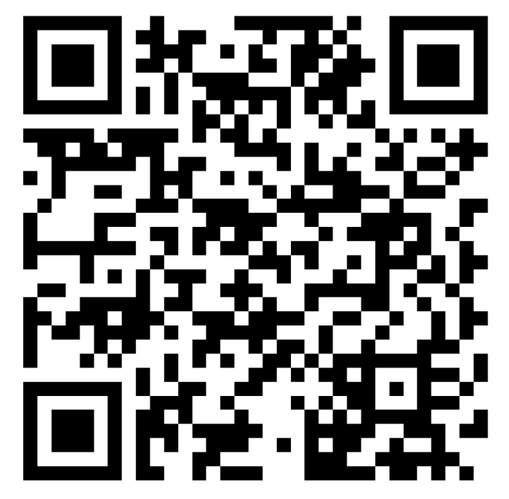
Contact Us
Ré – Centre for Exploratory Research
Kumaraguru College of Technology
Coimbatore
Contact:
Tharini S
+91 89252 26944
Tangapandian K M
+91 90425 57081
Email:
student.research@kct.ac.in

Follow Us
Stay connected with Ré for updates, research opportunities, events, and student projects.
Instagram: research.at.kct
LinkedIn: Ré – Centre for Exploratory Research

